Final Proposal (10% of Grade) and Project- yes it counts for the Final Exam
Target – Collaborative Worker: Discuss with partner(s) a PLAN to accomplish the Final Project.

You must type up a one page proposal.
It must be approved by the teacher before you start your project
The final Project must be graphical and should be interactive with the user—a game!?

Requirements:
*1 DS page MINIMUM
*Name of your group and members 2-3 max. If you have 3 people it had better be rigorous enough for warrant 3 people.
* Classes you are going to use and what they are going to do. Methods that you plan to develop for each class. How they will work with other classes.
* What will your graphical output look like?
*How will the User interact with program (click, keyboard)
*How will you accomplish this?
*What is each members be responsibility in the final program? Be specific.
!!! Submit CODE you will be using (graphics engine, Applet builder, etc. . . . )

You will receive multiple grade on this final: (1-5 10% each)
- Progress checks by the teacher
- Partner grades you on your contribution to the project.
- Class grade—you will present your project during class time and will be rated by the rest of the class. Something similar to the grid below.
- Proposal, CODE &/OR what have you developed so far
- Daily log

 | Subject Matter | Did this project demonstrate a knowledge of Java? v.s. just a demo of graphics. HOW? | How rigorous you think this project was.  Grade 1,2,3,4  Why? | Compare this project to the others today. Which ones would you give an A or F. Why?
Richa  Nina | Wheeele OF Fortune

Brandon John, Lucas Rezac
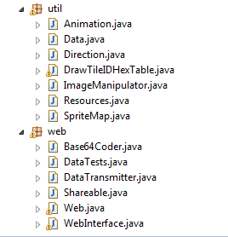
Our game is going to be an offshoot of Portal, in 2D. The maps will be loaded from a map file, such that we can easily make many maps for different levels. We will have many classes in use that I do not have time to explain all, as we already have 114 separate class files for use in this project. Here is an outline of our important classes that we already have:
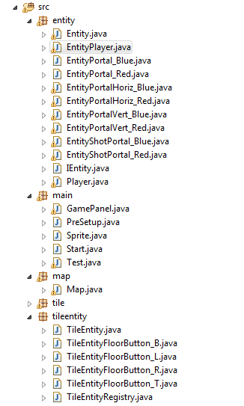
The most important classes are the GamePanel, which owns all graphics being drawn and controls very basic game logic. Entity keeps track of the different entities, and EntityPlayer is what runs the player logic, listens to the keyboard and the mouse, and owns the portal objects. Everything in the web package is used to make the game 2 player.

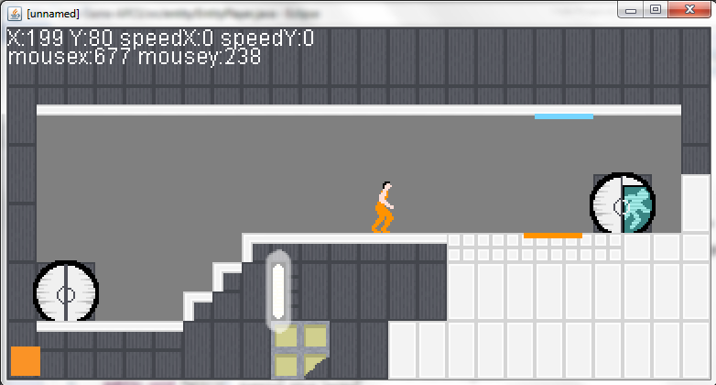
Here is what the game currently looks like while running: (This is showing debug info in the top left)

The user will interact with the keyboard WASD to move, and use the mouse to shoot portals and other keys for special functions. Brandon John is in charge of making the game multiplayer, as well as working on various parts of the game logic such as portals. Lucas is in charge of the Graphics as well as the graphics engine(that he wrote), and is also doing a large majority of entity interactions.

